Real Estate Architectural Models: The Ultimate Guide to Transforming Property Visualization and Sales
Real Estate Architectural Models: Benefits, Types & Complete Guide (2026)
Discover everything about real estate architectural models, including their benefits, types, manufacturing process, applications, and how they help developers attract investors and sell projects faster.
URL Slug:
/real-estate-architectural-models

Key Takeaways
- Real estate architectural models are physical scale representations that help visualize projects before construction begins.
- Professional architectural models improve buyer confidence, investor presentations, and property marketing.
- Different model types are designed for residential, commercial, industrial, and township developments.
- Modern architectural model making combines CAD design, laser cutting, CNC machining, 3D printing, and handcrafted detailing.
- Investing in a high-quality architectural model enhances communication, speeds up decision-making, and creates a lasting impression on stakeholders.

Real Estate Architectural Models: Bringing Future Developments to Life
Launching a real estate project is about much more than presenting blueprints or digital renderings. Buyers, investors, and stakeholders want to experience a project before it is built. While computer-generated images provide impressive visuals, they often fail to communicate scale, depth, and spatial relationships as effectively as a physical model.
This is where real estate architectural models become invaluable. These highly detailed miniature representations transform architectural concepts into tangible experiences, enabling clients to understand layouts, infrastructure, landscaping, and the overall vision of a project. From luxury villas and apartment complexes to industrial parks and smart cities, architectural models remain one of the most effective tools for visualization and marketing.
In this guide, you'll discover what real estate architectural models are, why they are essential, the different types available, and how they help developers, architects, and investors achieve better project outcomes.

What Are Real Estate Architectural Models?
A real estate architectural model is a physical, scaled-down representation of a proposed building or property development. It is created using architectural drawings, CAD files, and engineering plans to accurately showcase the design, layout, and surrounding environment before construction begins.
Unlike digital images viewed on a screen, architectural models allow viewers to examine a project from every angle. They provide a realistic understanding of building proportions, road networks, green spaces, parking areas, amenities, and the relationship between different structures.
Professional model makers use materials such as acrylic, MDF, PVC, resin, foam board, wood, and 3D-printed components to create highly detailed models. Many premium models also include LED lighting, moving elements, transparent sections, and removable components to enhance presentations.
Architectural models are widely used in:
- Residential apartment projects
- Villa communities
- Commercial complexes
- Shopping malls
- Hotels and resorts
- Industrial facilities
- Infrastructure developments
- Smart city projects
- Educational campuses
- Government planning initiatives
These models bridge the gap between technical drawings and real-world understanding, making them an essential communication tool.

Why Real Estate Architectural Models Matter
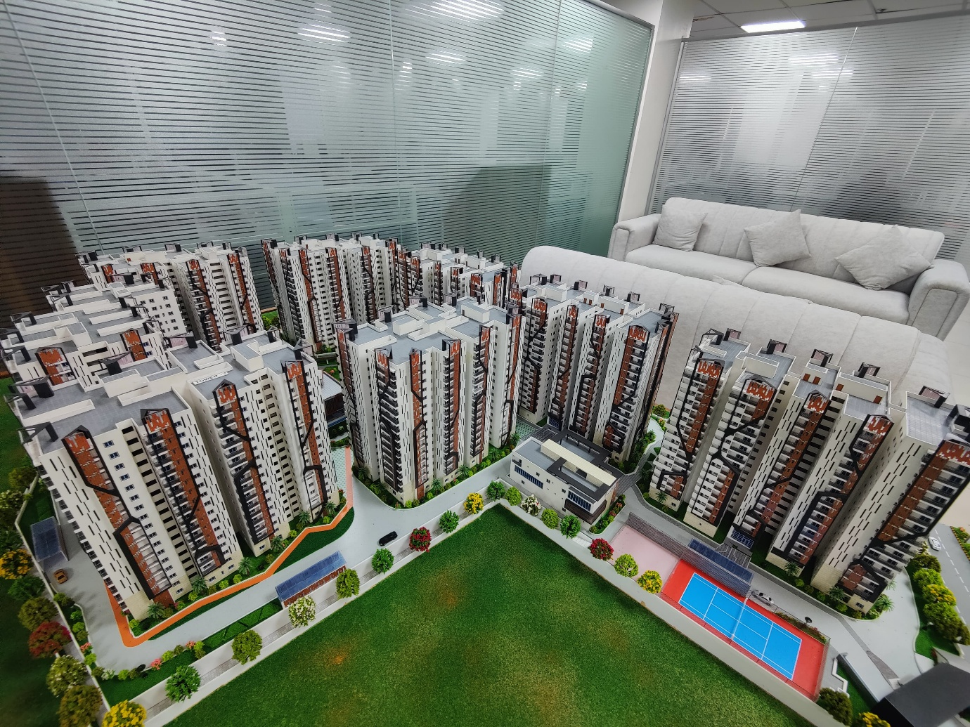
Architectural models continue to play a critical role in the real estate industry despite the rise of digital visualization technologies.
1. Enhanced Project Visualization
Many people find it difficult to interpret technical drawings or floor plans. A physical model instantly communicates the project's layout, proportions, and design, making complex concepts easy to understand.
2. Stronger Investor Confidence
Investors often make decisions based on how well they can visualize a development. A professionally crafted model demonstrates attention to detail, planning, and project quality, increasing confidence and credibility.
3. Better Marketing and Sales
Sales galleries equipped with architectural models create memorable experiences. Buyers can explore the entire development, understand unit locations, visualize amenities, and gain confidence in their purchasing decisions.
4. Improved Communication
Architectural models simplify communication between developers, architects, engineers, consultants, contractors, and clients. They reduce misunderstandings by presenting a shared visual reference.
5. Support for Government Approvals
Planning authorities frequently review large-scale developments using physical models. They make it easier to assess road connectivity, zoning, open spaces, environmental considerations, and overall project planning.
6. Competitive Advantage
In a competitive property market, an impressive architectural model differentiates a project from competitors. It creates a premium brand image and leaves a lasting impression during exhibitions, investor meetings, and sales presentations.

Types of Real Estate Architectural Models
Every development has unique visualization requirements. Choosing the right model depends on the project's scale, purpose, and audience.
Residential Architectural Models
These models showcase apartment buildings, gated communities, villas, and housing developments. They highlight building elevations, roads, gardens, clubhouses, swimming pools, parking areas, and recreational spaces.
Residential models are widely used in project launches, sales offices, and marketing campaigns to help homebuyers understand the overall community.
Commercial Architectural Models
Commercial models represent office buildings, business parks, shopping malls, hotels, mixed-use developments, and retail complexes.
These models emphasize accessibility, parking, circulation, landscaping, entrances, and public spaces, making them valuable for investor presentations and leasing discussions.
Township Models
Township models provide a comprehensive view of large-scale developments covering hundreds of acres. They include residential zones, commercial districts, schools, hospitals, parks, transportation networks, and utilities.
Because of their complexity, township models require exceptional planning and craftsmanship and are often the centerpiece of major real estate exhibitions.
Industrial Architectural Models
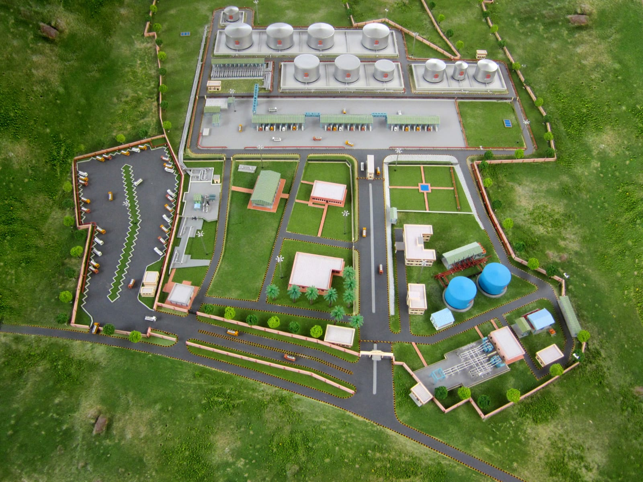
Industrial models are designed for factories, manufacturing plants, logistics hubs, warehouses, ports, refineries, steel plants, and energy facilities.
They illustrate production buildings, storage areas, transportation routes, utilities, safety infrastructure, and operational workflows. These models are frequently used for project approvals, corporate presentations, and employee training.
Master Planning Models
Master planning models help visualize urban developments, institutional campuses, airports, railway stations, infrastructure projects, and smart cities.
They present the broader relationship between roads, transportation systems, green spaces, utilities, and future expansion, making them valuable tools for long-term planning and stakeholder engagement.

How Are Real Estate Architectural Models Made?
Creating a high-quality real estate architectural model is a meticulous process that combines engineering precision, artistic craftsmanship, and advanced manufacturing technologies. Every model is custom-built to reflect the architect's vision while accurately representing the project's dimensions, materials, and surroundings.
1. Project Consultation and Planning
The process begins with a detailed discussion between the client and the model-making team. Developers provide architectural drawings, CAD files, BIM models, landscape plans, elevation drawings, and project specifications. At this stage, important decisions such as the model's purpose, display location, scale, level of detail, and timeline are finalized.
2. Selecting the Right Scale
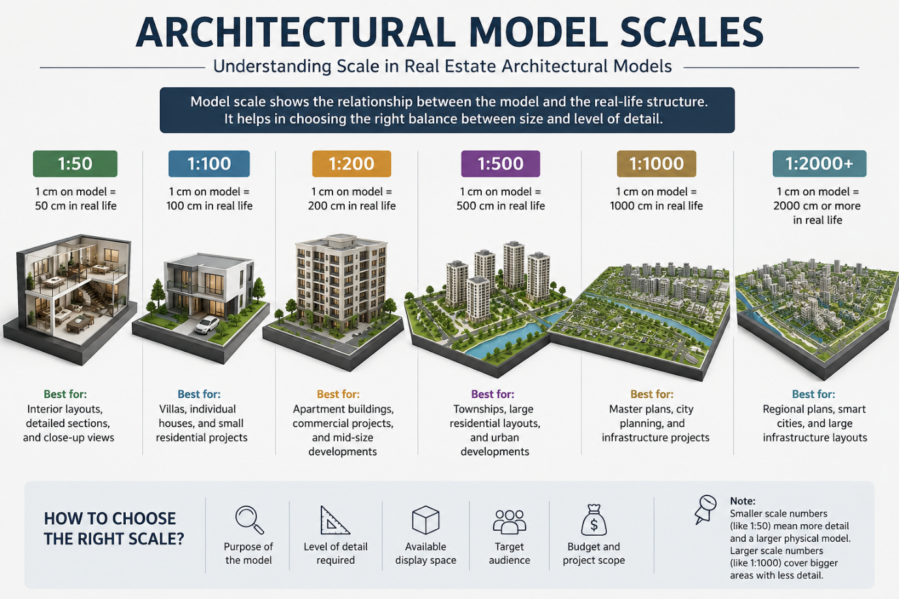
Choosing the appropriate scale is crucial because it determines the balance between overall size and the level of detail that can be displayed.
Common scales include:
- 1:50 – Interior layouts and detailed building sections
- 1:100 – Residential buildings and villas
- 1:200 – Apartment complexes and commercial buildings
- 1:500 – Township developments
- 1:1000 or smaller – Master plans and infrastructure projects
The selected scale depends on the available display space and the amount of information that needs to be showcased.
3. Digital Design Preparation
Before fabrication begins, the design team converts architectural drawings into digital manufacturing files. Software such as AutoCAD, Revit, SketchUp, Rhino, and other 3D modeling tools are used to prepare components for laser cutting, CNC machining, and 3D printing.
This stage ensures that every wall, road, landscape feature, and structural element is accurately represented.
4. Material Selection
The choice of materials directly influences the model's appearance, durability, and realism.
Common materials include:
- Acrylic for transparent elements such as windows and water features
- MDF for structural support
- Foam board for lightweight terrain
- PVC sheets for precision components
- Resin for intricate architectural details
- PLA and ABS for 3D-printed elements
- Metal components for specialized industrial models
- LED lighting for nighttime effects
Professional model makers often combine multiple materials to achieve the most realistic finish.
5. Precision Manufacturing
Once the files are prepared, advanced manufacturing technologies are used to fabricate individual components.
These include:
- Laser cutting for clean edges
- CNC machining for structural accuracy
- 3D printing for complex geometries
- UV printing for roads, textures, and graphics
These technologies ensure consistency and precision while reducing production time.
6. Hand Assembly and Detailing
Although machines produce many components, much of the model's realism comes from handcrafted detailing.
Skilled artisans carefully assemble buildings, roads, trees, streetlights, vehicles, water bodies, and landscape elements. Every component is inspected for alignment and accuracy before final assembly.
7. Lighting and Interactive Features
Premium architectural models often include:
- LED street lighting
- Illuminated buildings
- Interactive lighting zones
- Push-button lighting controls
- Motorized moving elements
- Digital displays
- Touchscreen integration
These features create engaging presentations for investors and buyers.

Applications of Real Estate Architectural Models
Architectural models are used far beyond property sales. Their ability to simplify complex designs makes them valuable across multiple industries.
Property Sales Galleries
Sales offices frequently use scale models to help buyers understand apartment locations, amenities, open spaces, and road connectivity. A well-designed model creates confidence and helps buyers visualize their future investment.
Investor Presentations
Investors often prefer physical models because they provide a complete understanding of a project's scale and development strategy. Models communicate information quickly and effectively during funding discussions.
Trade Shows and Exhibitions
Architectural models attract attention at real estate expos, industrial exhibitions, and infrastructure events. A detailed scale model serves as a focal point, encouraging meaningful conversations with potential clients and investors.
Government and Planning Authorities
Large infrastructure and urban development projects often require physical models for planning reviews and approvals. These models help authorities evaluate transportation networks, public spaces, zoning, and environmental impact.
Educational Institutions
Architecture and engineering colleges use models as teaching tools to explain structural concepts, urban planning, and design principles.

How to Choose the Right Architectural Model Maker
Selecting the right model-making company is just as important as the model itself.
Consider the following factors:
Experience
Look for a company with proven expertise in residential, commercial, industrial, and infrastructure projects. A strong portfolio demonstrates the ability to handle projects of varying complexity.
Technology
Choose a model maker that uses modern technologies such as laser cutting, CNC machining, 3D printing, and digital fabrication alongside skilled hand-finishing.
Attention to Detail
High-quality models accurately represent architectural features, landscaping, roads, lighting, textures, and surrounding environments. Small details often make the biggest impression.
Customization
Every project is unique. The ideal model maker should offer customized solutions rather than one-size-fits-all designs.
Delivery and Support
Timely delivery, safe transportation, installation, and after-sales support are essential, especially for large exhibition models.

Future Trends in Architectural Model Making
While digital visualization continues to evolve, physical architectural models are becoming more sophisticated rather than obsolete.
Emerging trends include:
- Integration with Augmented Reality (AR)
- Interactive touch-screen displays
- Smart LED lighting systems
- Sustainable and recyclable materials
- Modular models for easy transportation
- AI-assisted manufacturing workflows
- High-resolution resin 3D printing
- Hybrid physical and digital presentations
These innovations make architectural models even more valuable for marketing, planning, and stakeholder engagement.

Frequently Asked Questions
Are architectural models still relevant in the age of 3D rendering?
Yes. Digital renders provide immersive visuals, but physical models offer a tangible understanding of scale, proportions, and spatial relationships that screens cannot fully replicate.
How long does it take to build an architectural model?
Production time depends on the project's size and complexity. Small residential models may take a few weeks, while large township or industrial models can require several months.
What industries use architectural models?
Besides real estate, architectural models are widely used in industrial manufacturing, infrastructure, transportation, education, healthcare, government planning, hospitality, and urban development.
Are illuminated models worth the investment?
Absolutely. LED lighting enhances presentations by highlighting roads, buildings, amenities, and landscape features, making projects more engaging for buyers and investors.

Conclusion
Real estate architectural models remain one of the most effective visualization tools available to developers, architects, and marketers. By transforming technical drawings into realistic three-dimensional representations, these models make complex projects easier to understand, improve communication, and inspire confidence among investors, buyers, and planning authorities.
Although technologies such as virtual reality and 3D rendering continue to evolve, physical architectural models offer a unique, tangible experience that digital media cannot replace. They enable stakeholders to appreciate a project's scale, design, and surroundings from every angle, making them invaluable for sales galleries, exhibitions, investor meetings, and government approvals.
Whether you are launching a luxury residential community, a commercial development, an industrial facility, or a smart city project, investing in a professionally crafted architectural model is an investment in clearer communication, stronger marketing, and long-term project success.
Ready to Showcase Your Next Project?
If you're looking to create a premium architectural model that captures attention and communicates your vision with precision, partner with an experienced model-making company that combines advanced manufacturing technologies with exceptional craftsmanship. A well-designed architectural model doesn't just represent your project—it tells its story and helps turn your vision into reality.

